BITBUCKET

Name-K.Akash

RegNo-21011102045

1)Clone the repo

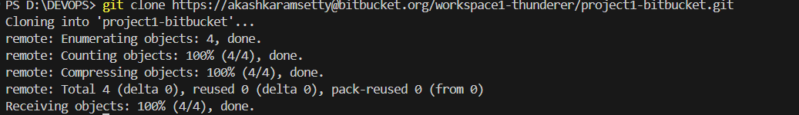

2)Creating a new file

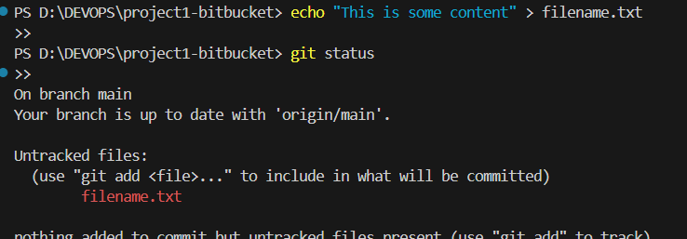

3)adding the new file to the line up , commiting the changes

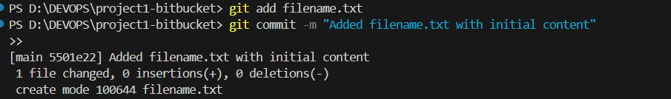

4)Creating a new branch “feature” and adding the changes to it

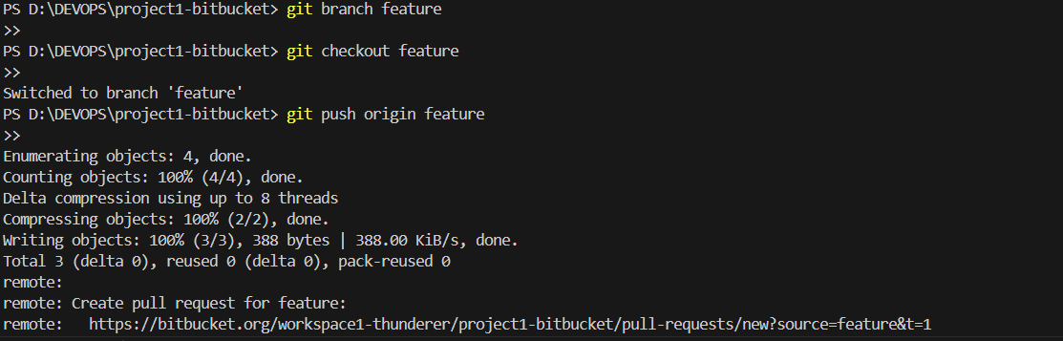

5)adding the changes to repo in the bitbucket  


6)Created the pull request with necessary inputs (title,description):

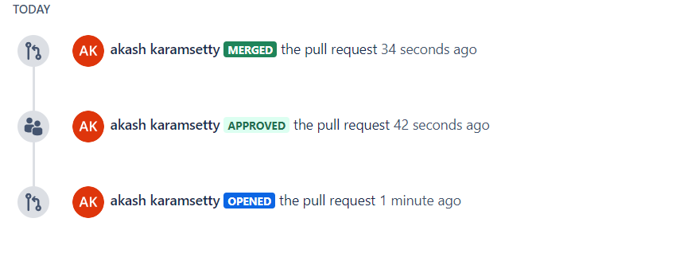

7) Intiated the merge sequence of the branch

